

**Wireframe Document**

**HEART DISEASE DIAGNOSTIC ANALYSIS**



**We conducted an exploratory data analysis using Jupyter Notebook, followed by creating a dashboard in Tableau Desktop.**

**1. Demographic Breakdown and Heart Disease Prevalence**

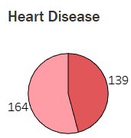 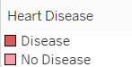

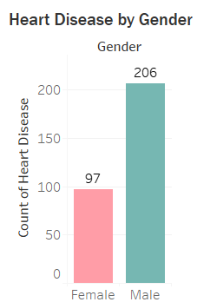 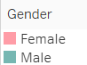

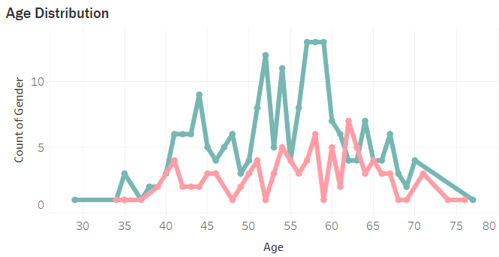

* Approximately 45% of the individuals in the dataset have heart disease.
* Males are more than twice as likely as females to have heart disease, with counts of 206 and 97, respectively.
* The age distribution shows two notable peaks in heart disease occurrence: one between ages 55 to 60 and another, less pronounced, around age 65.
* The occurrence of heart disease in both males and females follows a similar age distribution, with a higher frequency observed in males across most age groups.
* The frequency of heart disease begins to rise around age 40 for both genders, with a sharp increase from age 50 onwards.

**2. Age-Related Heart Disease Incidence Patterns**

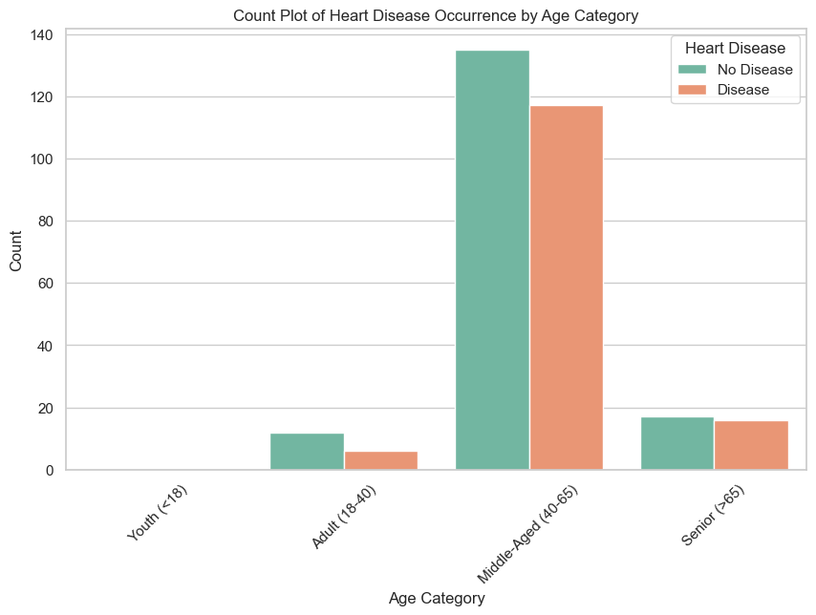

* Heart disease occurrence peaks significantly in the middle-aged category (40-65).
* The adult age group (18-40) shows notably fewer cases of heart disease.
* Seniors (over 65) have a lower count of heart disease cases compared to the middle-aged group, but still more than the adults.
* The distribution suggests that the risk of heart disease is notably higher in middle age.

**3. Clinical Profiles and Symptom Patterns in Heart Disease**

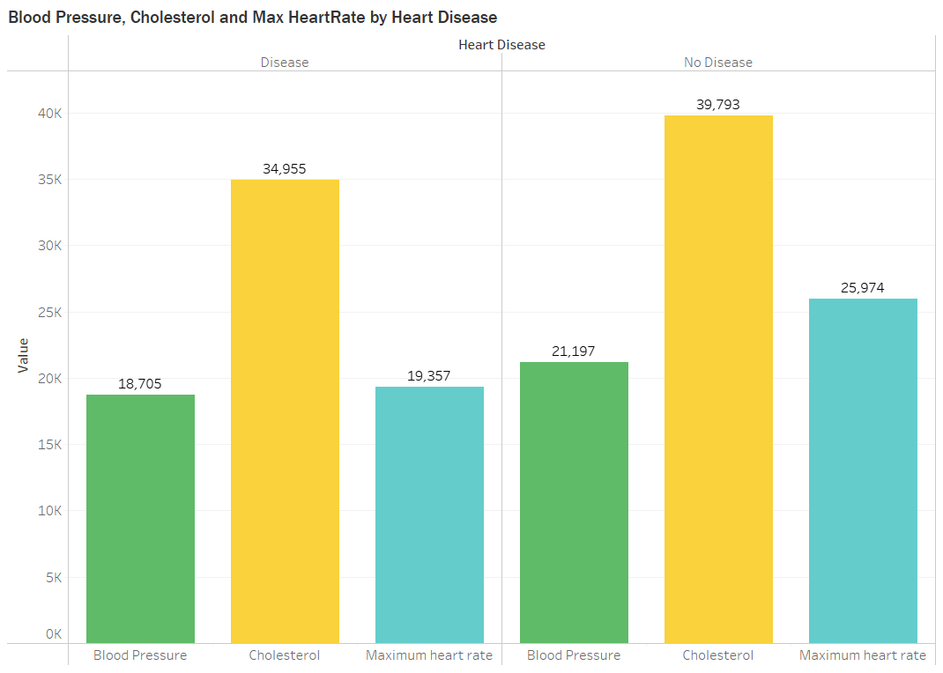

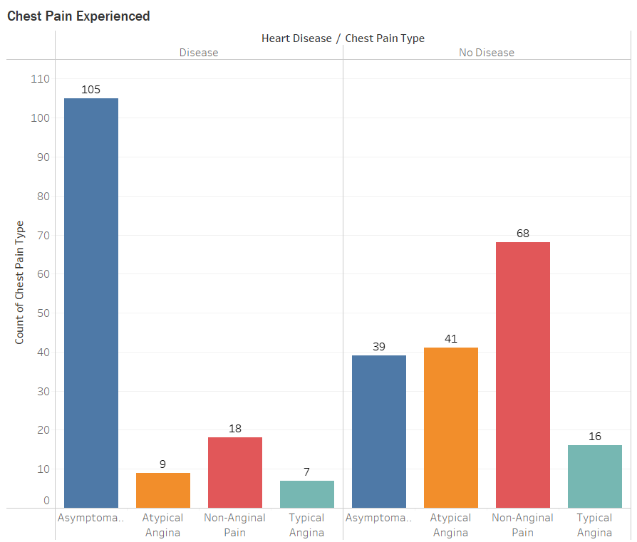

* Asymptomatic chest pain is the most common type reported among individuals with heart disease.
* Individuals without heart disease most frequently report non-anginal pain.
* Typical angina is more commonly reported by individuals with heart disease than those without.
* Total cholesterol levels are higher among individuals without heart disease in the data collected.
* Blood pressure and maximum heart rate values are comparatively lower in individuals with heart disease than those without.
* The data suggests the need to consider factors beyond cholesterol, blood pressure, and heart rate alone for heart disease prediction.

**3. Gender Disparity in Elevated Fasting Blood Sugar Levels**

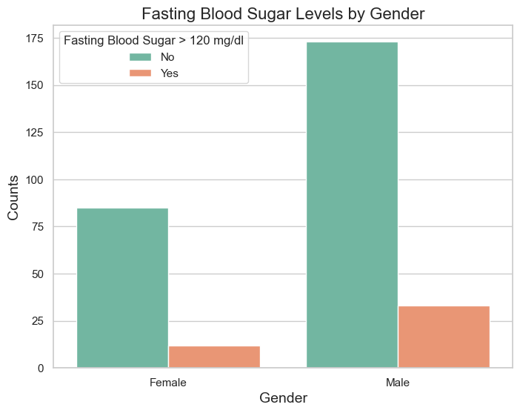

* A greater number of males have fasting blood sugar levels above 120 mg/dl compared to females.
* The majority of both genders have fasting blood sugar levels below 120 mg/dl.

**4. Variations of ST Depression Across Age in Heart Disease**

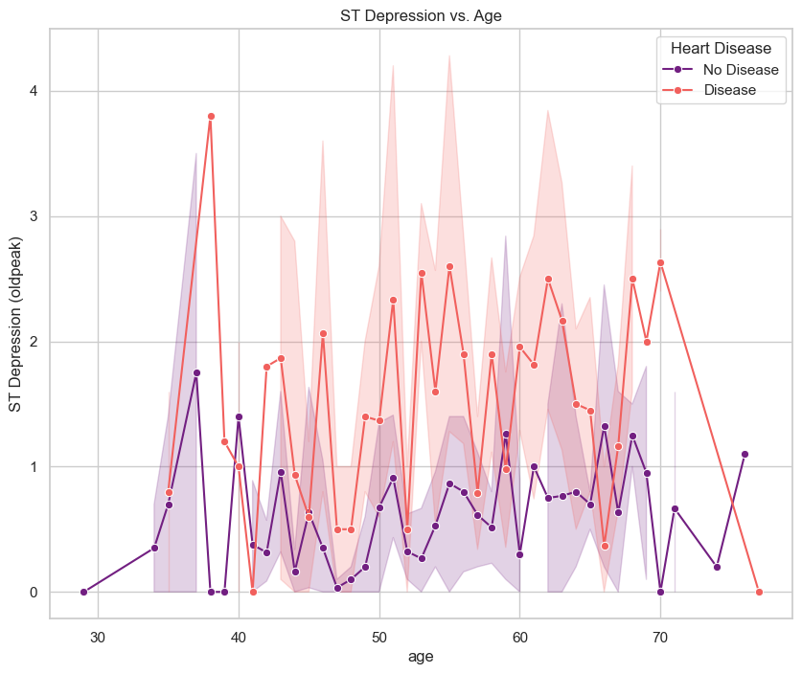

* ST depression is observed across all age groups, with variability in its occurrence.
* There are peaks in ST depression at various ages, with no clear progressive increase or decrease with age.
* Both individuals with and without heart disease exhibit ST depression, but it's more pronounced in those with the disease.